HW3 - MySQL – Dec 2019

#1. Find the bowlers who had a raw score of 155 or better at Thunderbird Lanes combined with bowlers who had a raw score of 140 or better at Bolero Lanes.

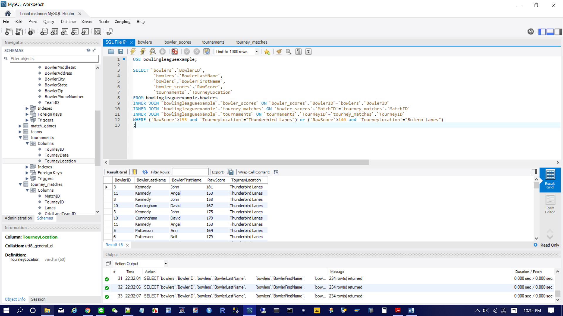

#2. Show me the vendors and the products they supply to us for products that cost less than $100

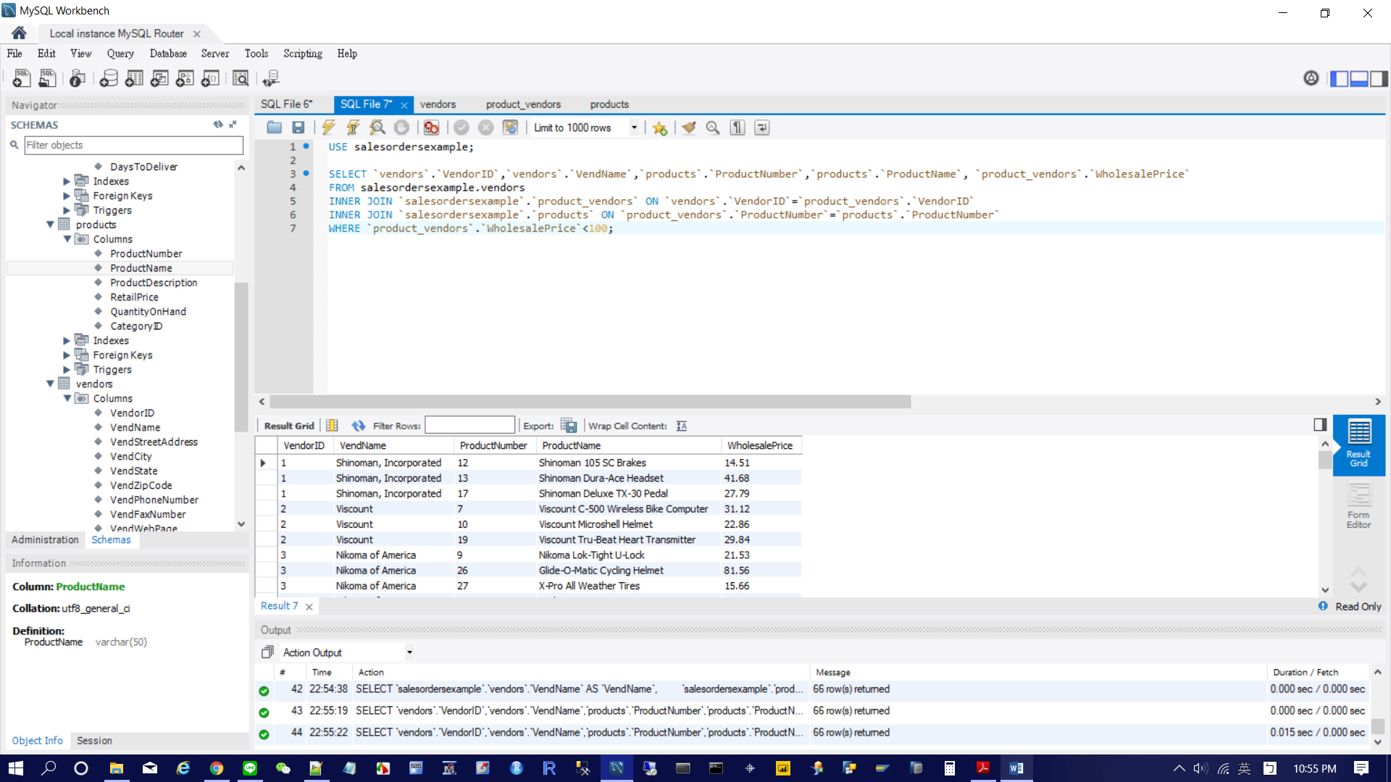

#3. Find the agents and entertainers who live in the same postal code.

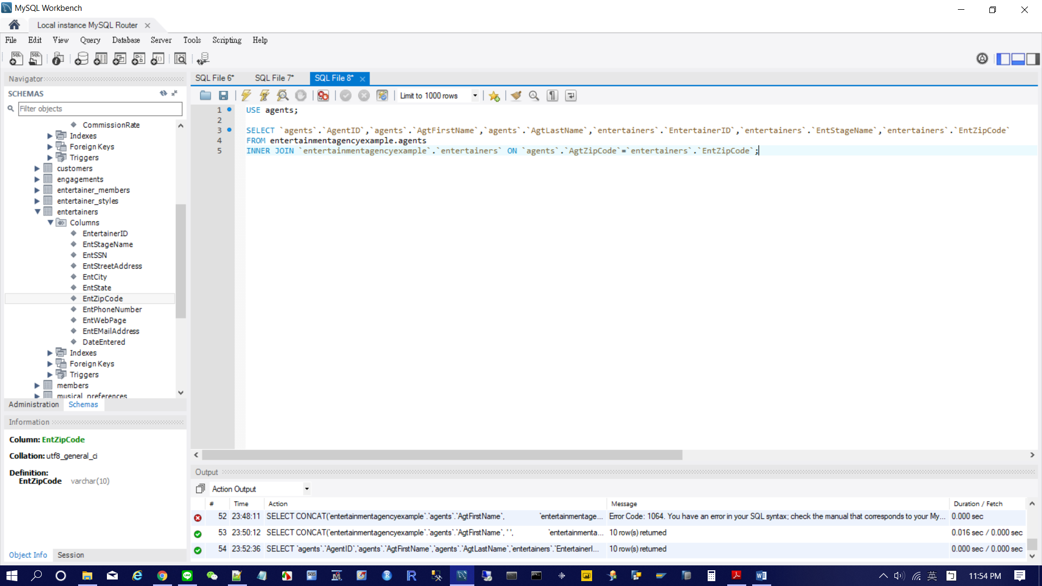

#4. Display all recipe classes and any recipes that might be associated with them.

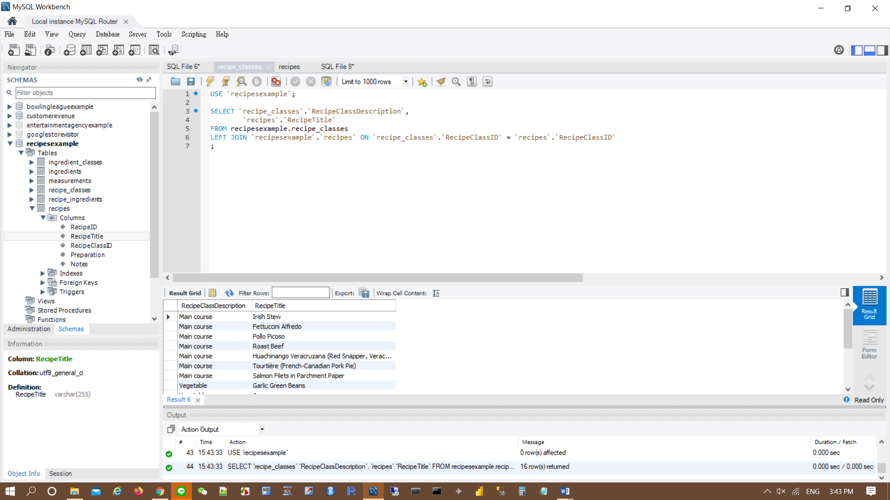

#5. What products have never been ordered?

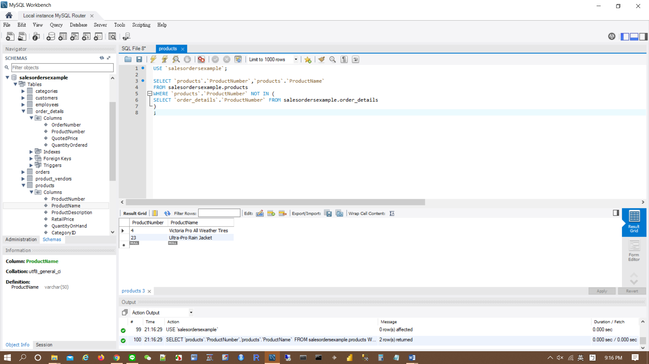

#6. List the subjects taught on Wednesday.

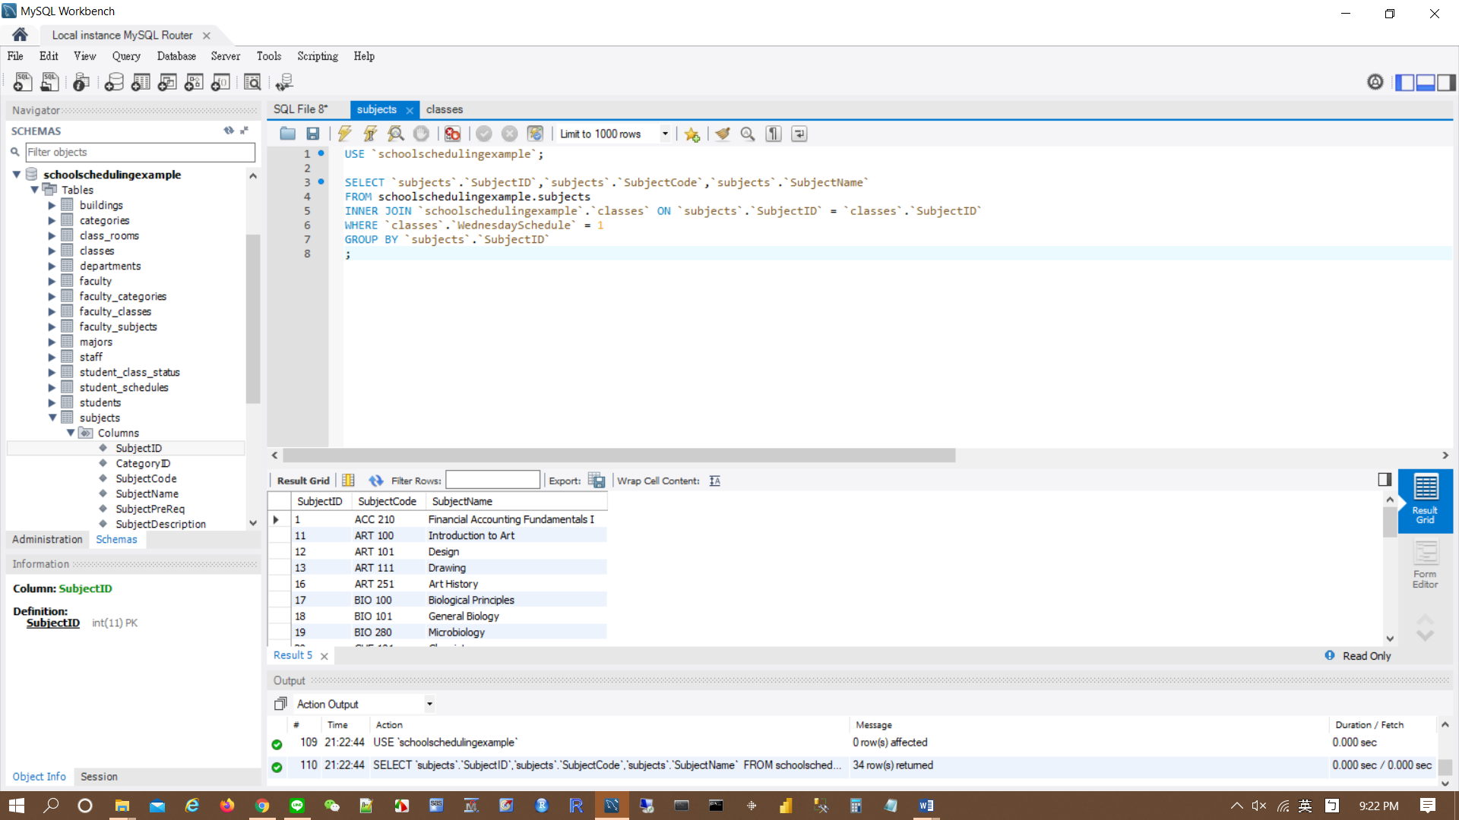

#7. Find the entertainers who played engagements for customers Berg or Hallmark.

